Letting Go of Hate

Torah, Vayikra 19:17-18
Do not hate your brother in your heart ...

Jerusalem Talmud Yoma 1:1
In every generation that the Beis Hamikdash (the Holy Temple) is not rebuilt, it is as if in that in that generation it was destroyed.

Talmud Yoma 9b
The First Beis Hamikdash (Holy Temple) was destroyed because of the three cardinal sins: idolatry, illicit relations, and murder. The Second Beit Hamikdash, though, was destroyed on account of baseless hatred.
… the conclusion is that baseless hatred is akin to the three cardinal sins.

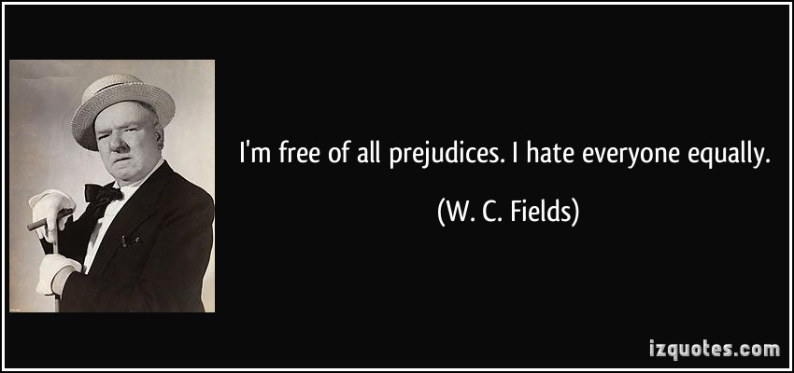
# 1
Pirkei Avos 2:16
Rabbi Joshua would say: An evil eye, the evil inclination, and the hatred of one's fellows, drive a person from the world.

(a) Question: How do these things remove person from the world?
Which world are we talking about?
Rashi
“And the hatred of one's fellows”: This refers to baseless hatred.

(b) Question: What is baseless hatred and what is the opposite of it?

#2
Sanhedrin, Mishnah3:5
A “hater” is disqualified from giving testimony in court about someone whom he hates. A “hater” is someone who has not spoken to his friend out of hatred for three days.

James Arthur Baldwin
I imagine one of the reasons people cling to their hates so stubbornly is because they sense, once hate is gone, they will be forced to deal with pain.

Question: Why do we hate others?
Is it possible to quantify the level of hatred?

#3
Derech Eretz Rabbah 11
One who hates his friend is like someone who spills his blood.

Question: How is hatred akin to murder?

#4
Torah, Devarim 23:8
… Do not hate an Egyptian, because you were a stranger in his land.

The Egyptians attempted genocide - Pharaoh commanded his people to throw “every male [Israelite] child born, into the river” (Torah, Shmos 1:22).
Now, forty years later, Moses speaks as if none of this had happened, as if the Israelites owed the Egyptians a debt of gratitude for their hospitality. Yet he and the people were where they were only because they were escaping from Egyptian persecution. Nor did he want the people to forget it. To the contrary, he told them to recite the story of the Exodus every year, as we still do on Passover, re-enacting it with bitter herbs and unleavened bread so that the memory would be passed on to all future generations. If you want to preserve freedom, he implies, never forget what it feels like to lose it. Yet here, on the banks of the Jordan, addressing the next generation, he tells the people, “Do not hate an Egyptian”.
Question: What is going on in this verse?

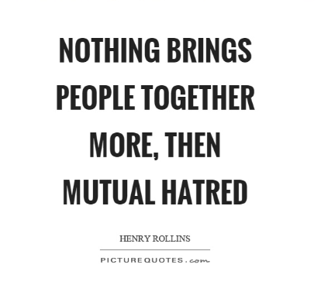
#5
Rav Kook, Orot HaKodesh vol. III, p. 324
If we were destroyed, and the world with us, due to baseless hatred, then we shall rebuild ourselves, and the world with us, with baseless love.

Avos D’Rabbi Noson 23
Who is strong? The one that makes his enemy into his friend.

Martin Luther King
Darkness cannot drive out darkness: only light can do that. Hate cannot drive out hate: only love can do that. Hate multiplies hate, violence multiplies violence, and toughness multiplies toughness ...

Question: Is it possible to overcome hatred? If yes - how?

#6
Talmud Bava Metzia 32b
If a friend requires help unloading his animal which has fallen because under a heavy burden (normally such an obligation has priority because of the animal’s suffering), and an enemy’s animal requires loading (which would normally be secondary because it adds to the discomfort of an animal), one’s prior obligation is toward his enemy, in order to subdue his evil inclination (the default inclination being to offer no help to one’s enemy).

Questions:
Why would the Torah “bend" it's rules in order to teach us not to follow our base desires?
Could we apply this idea to our daily lives?

#7
The Writings, Koheles (Ecclesiastes)
3:1 To every thing there is a season, and a time to every purpose under the heaven:
3:8 A time to love, and a time to hate; a time of war, and a time of peace.

Talmud Shabbos 31a
There was another incident involving one gentile... who came before Hillel. He converted him and said to him: That which is hateful to you do not do to another; that is the entire Torah, and the rest is its interpretation. Go study.

Question: When is hatred appropriate?

#8 Question: What is your takeaway from today’s discussion?

